Chapter 7, Problem 35.

Find the solution to the following differential equations
(a) 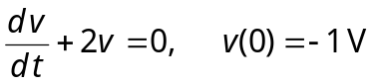
(b) 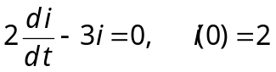A

